PCA-SIMS Spectra Analysis Report

**Low P (positive ions)**

ToF-SIMS testing date: 20230810

ToF-SIMS operator: Chris Pasture

# 2D PCA scores plots

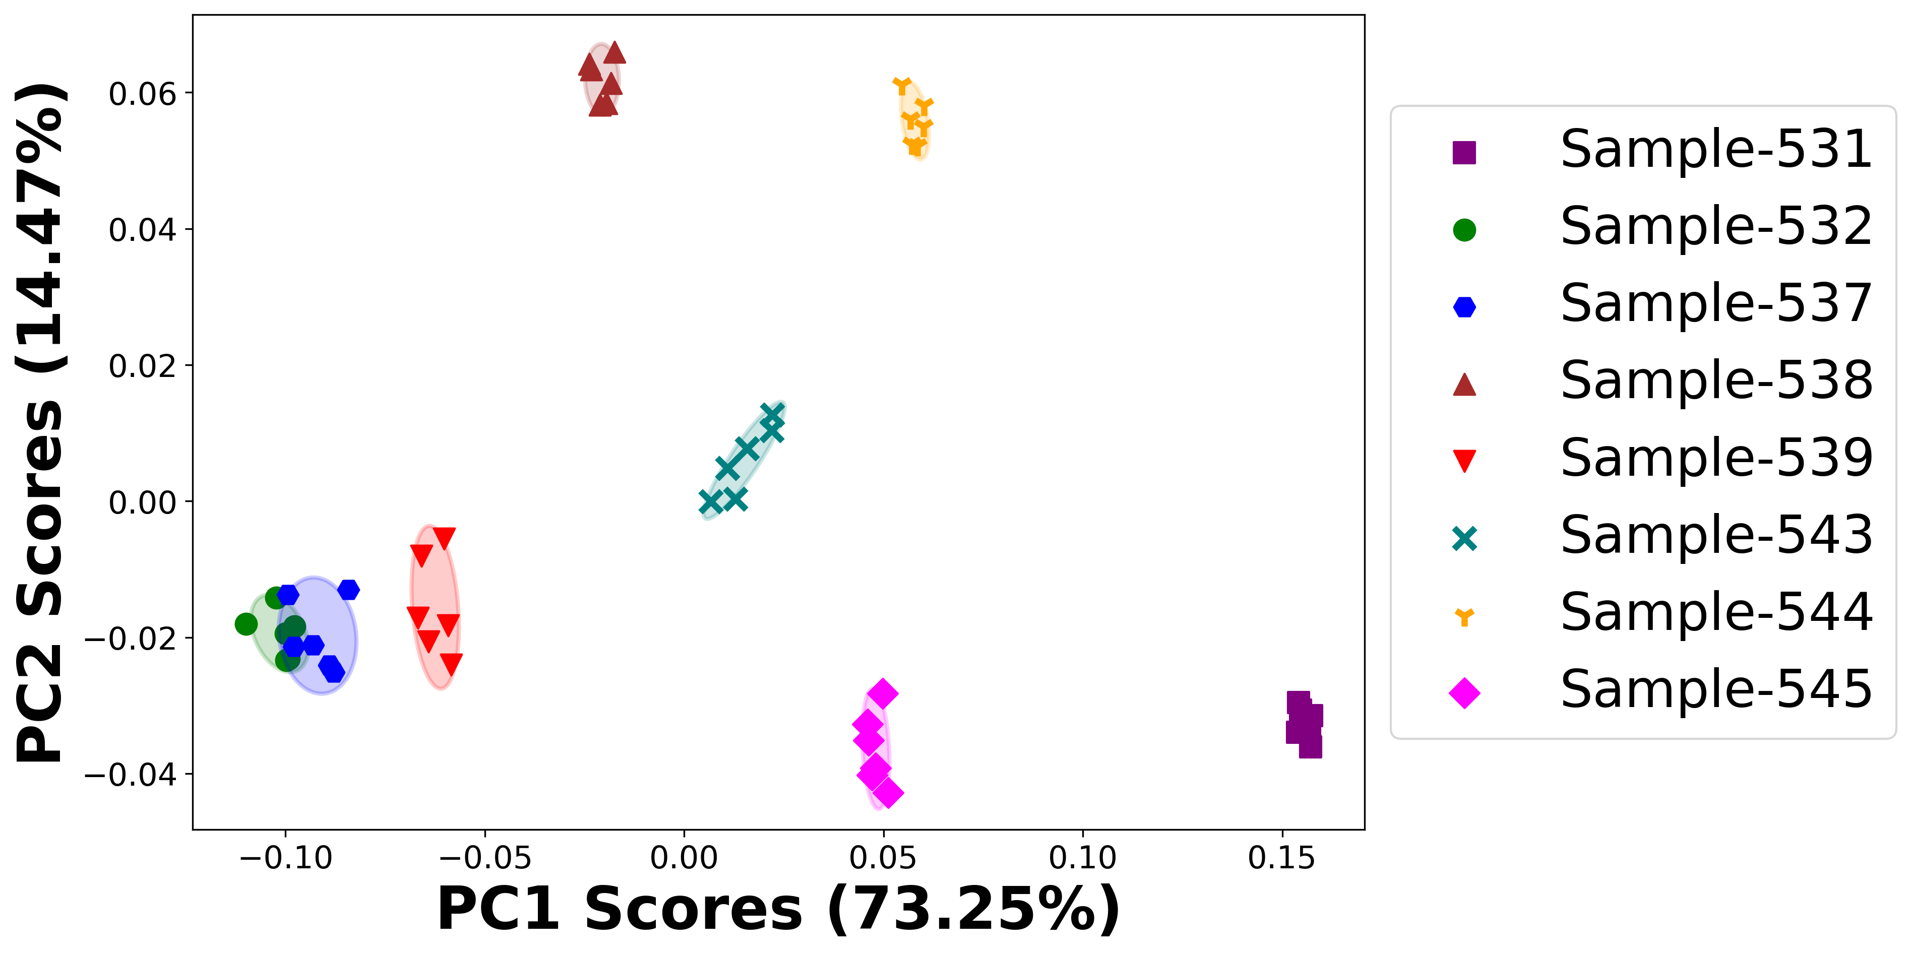

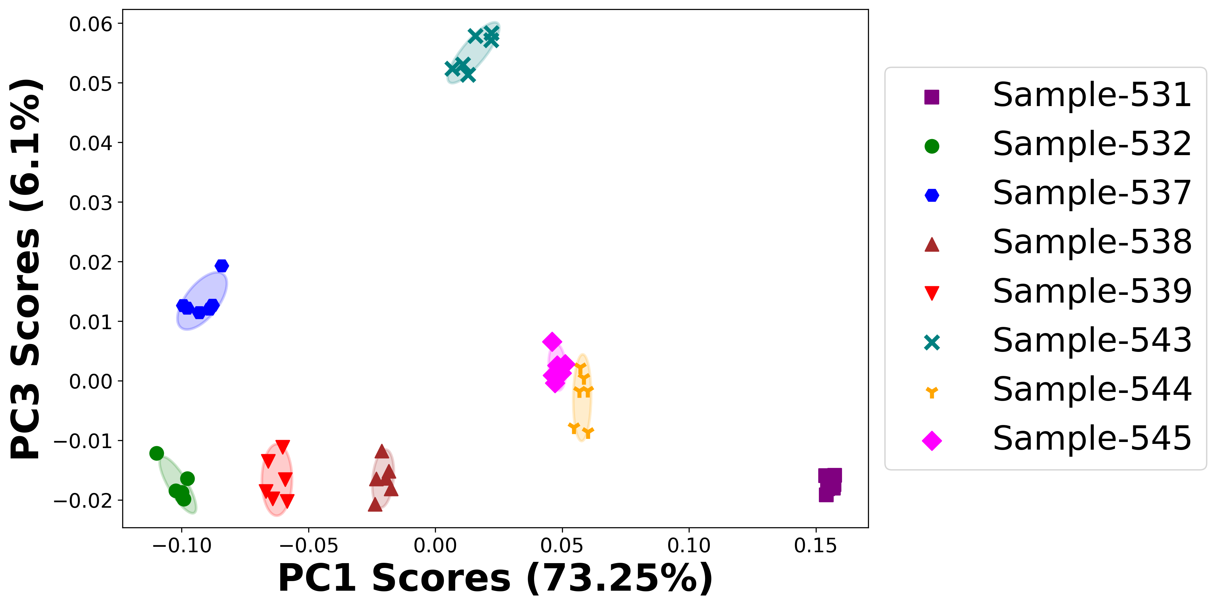

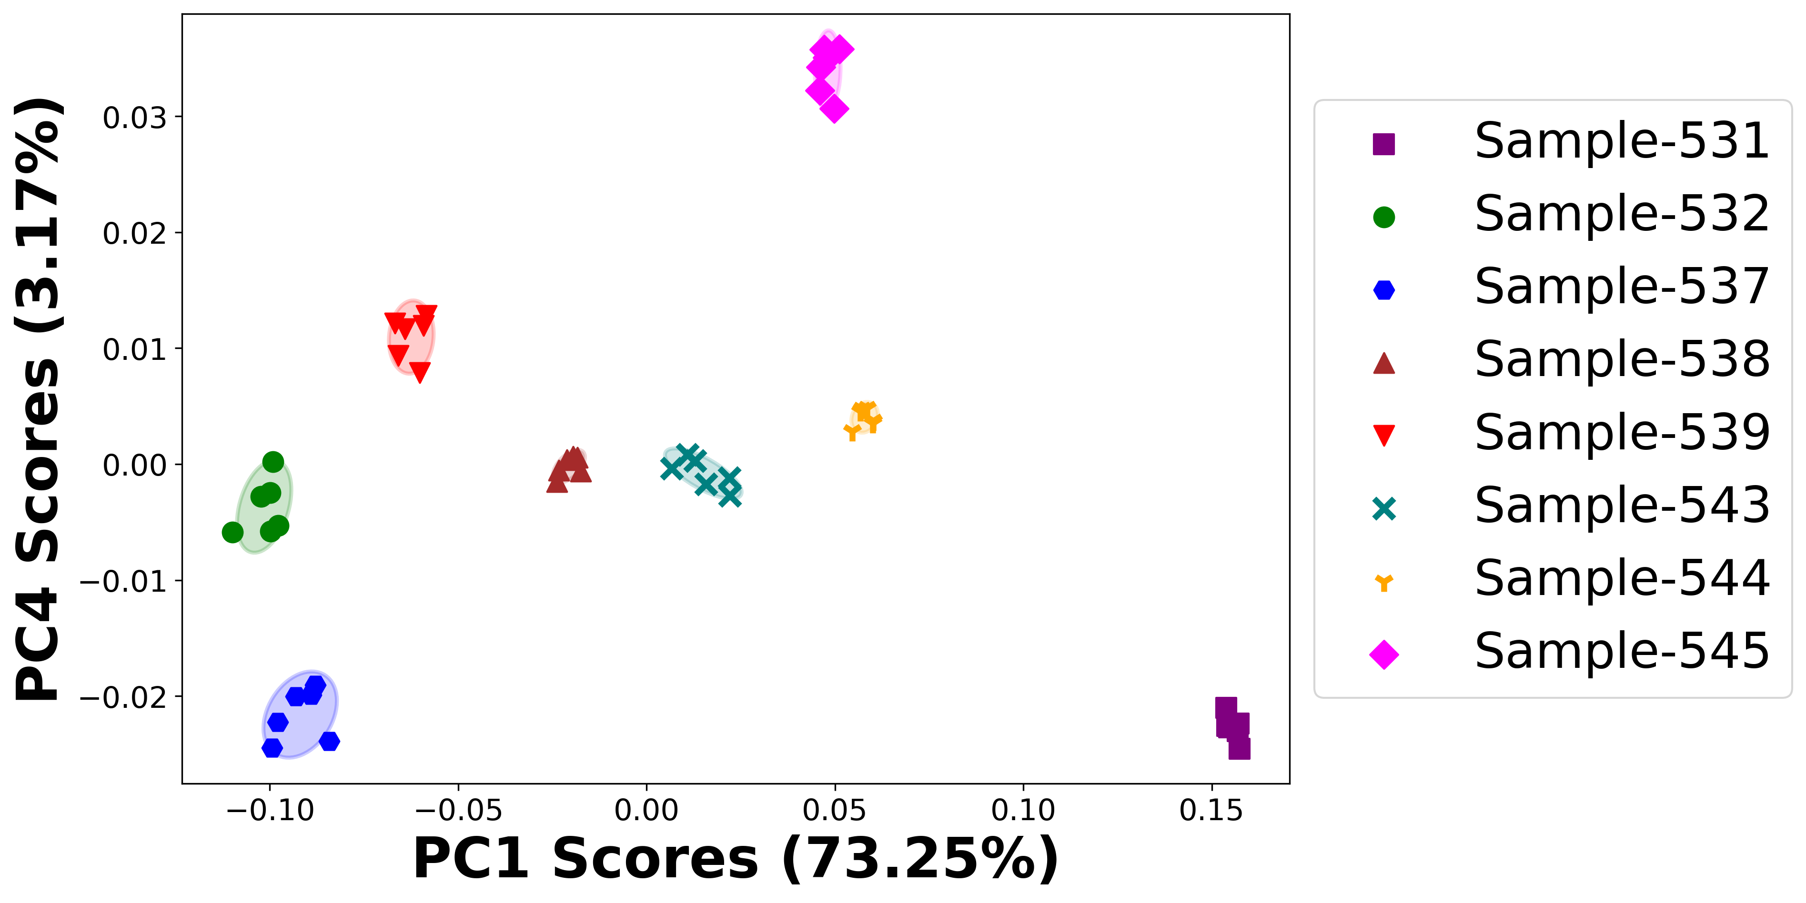

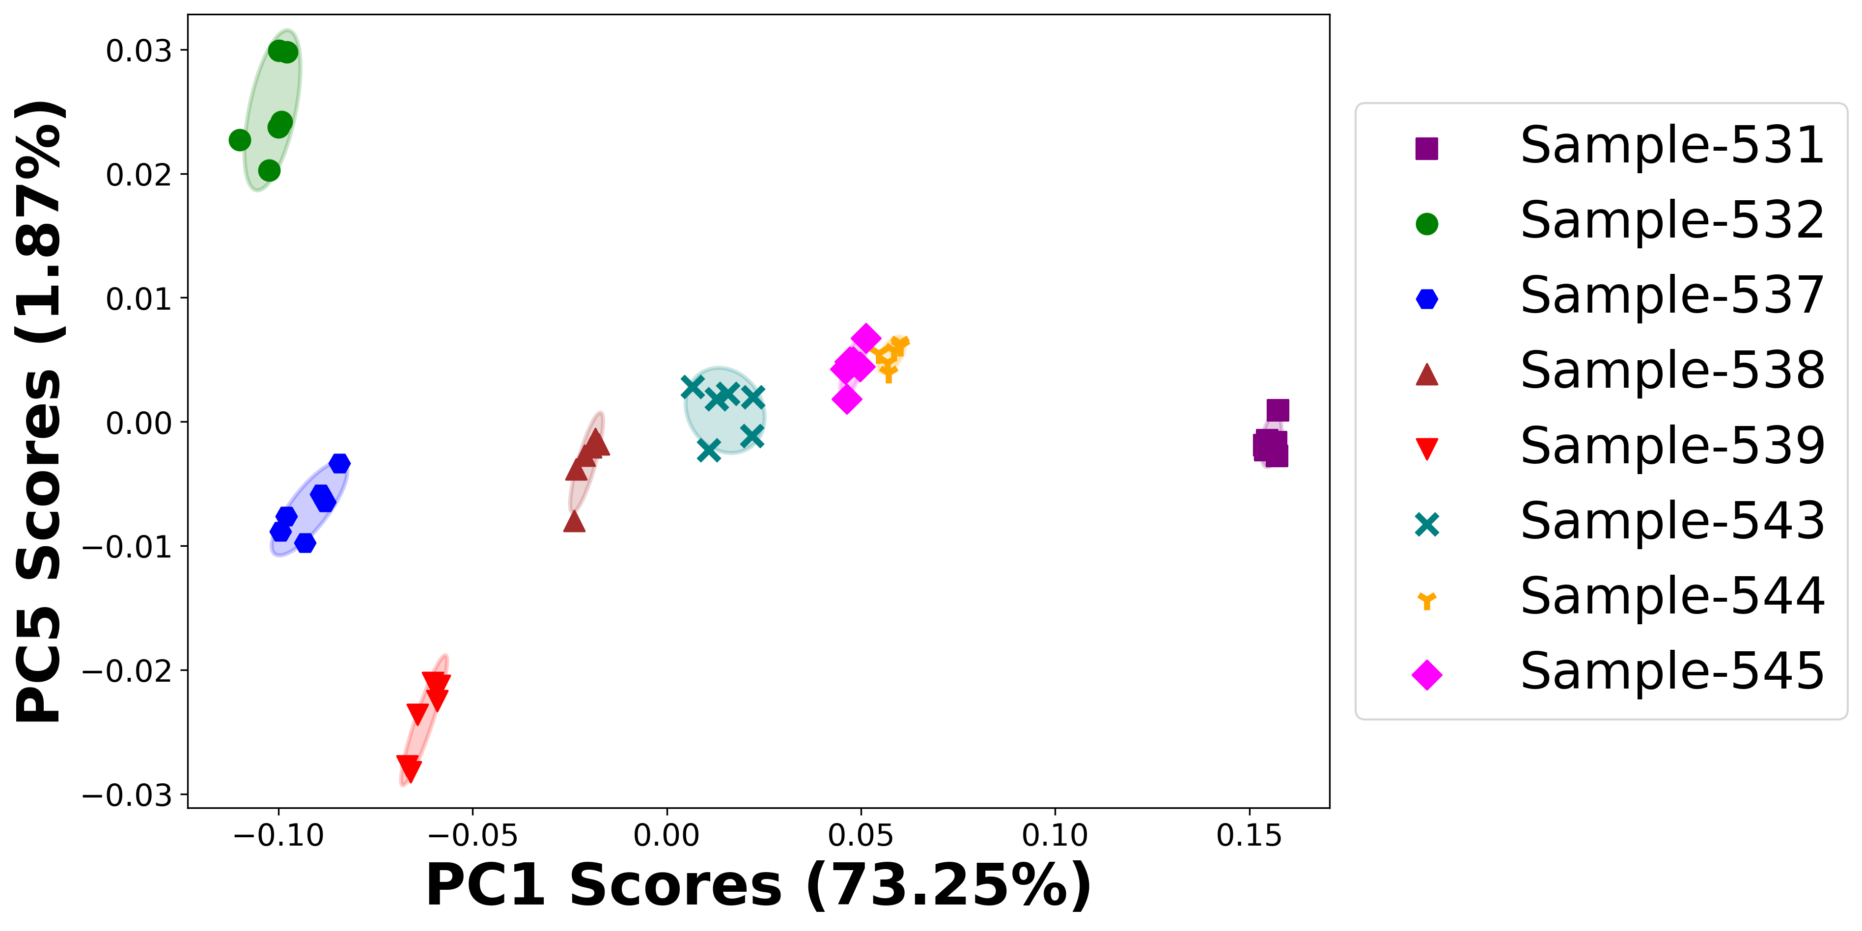

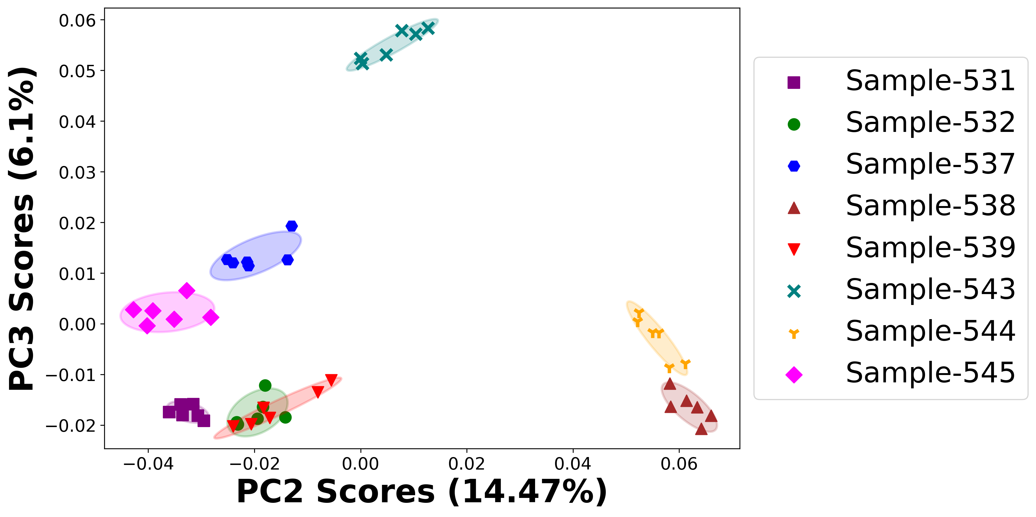

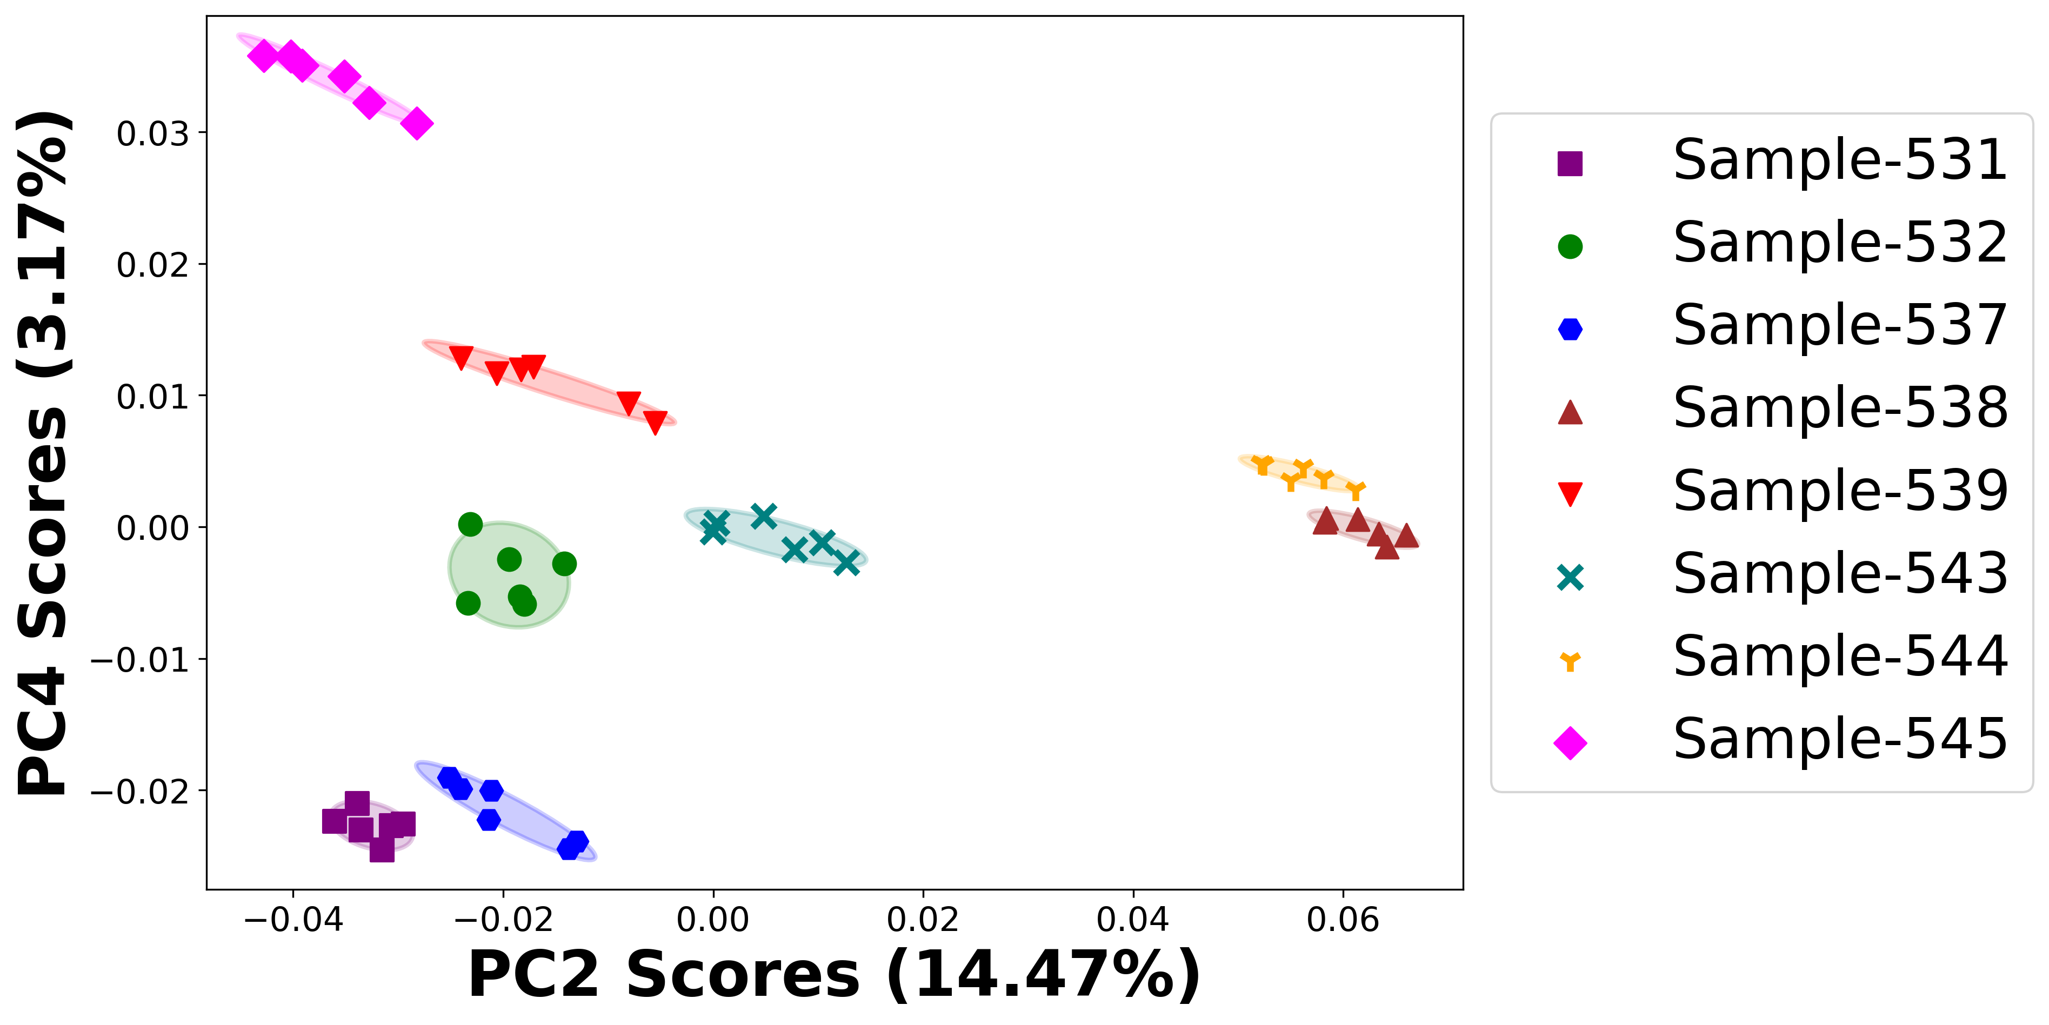

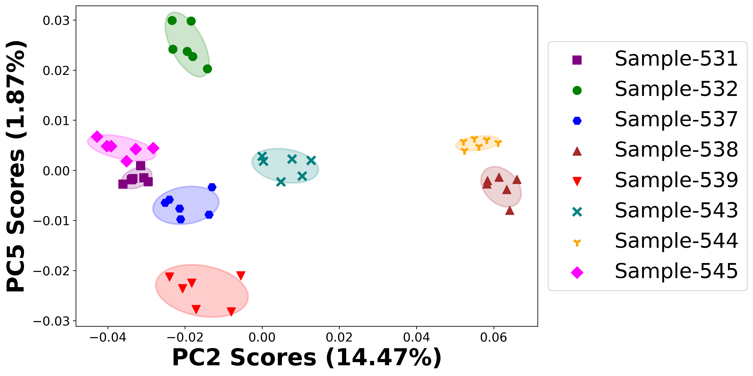

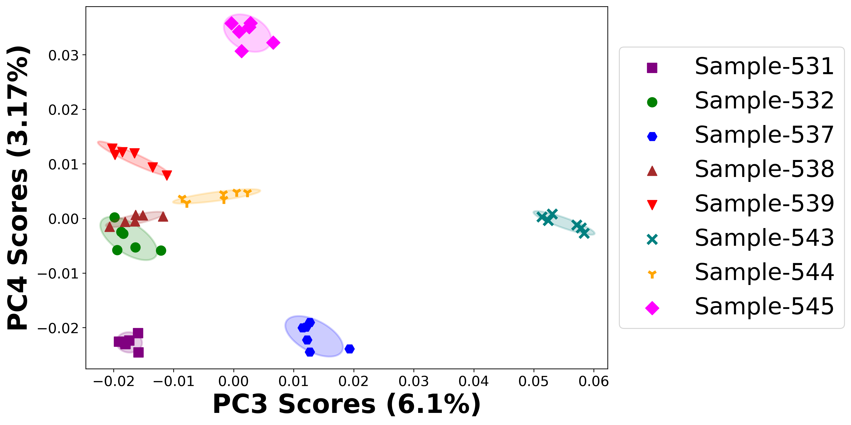

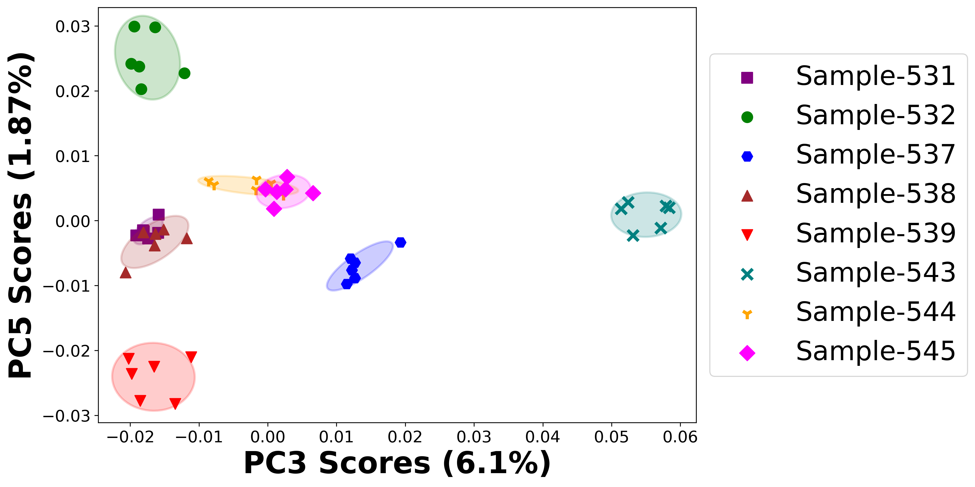

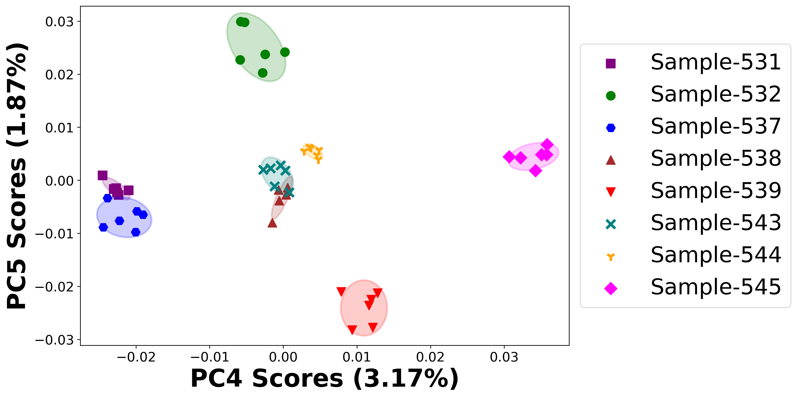

# Positive ion spectra, PCA analysis results -- PC1

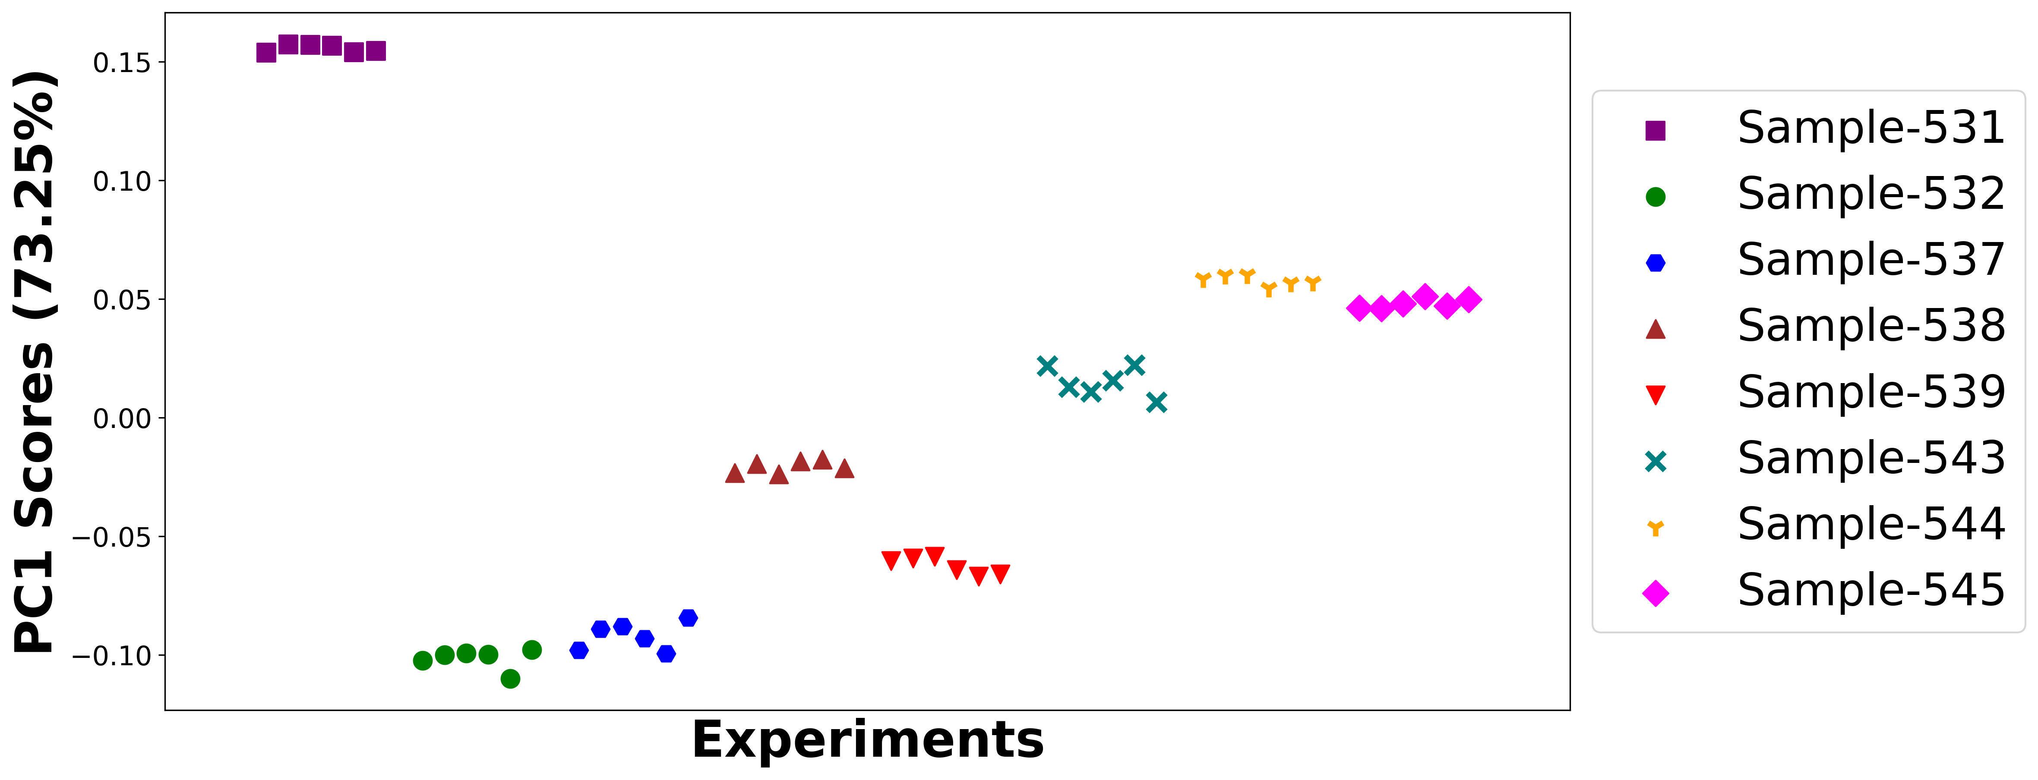

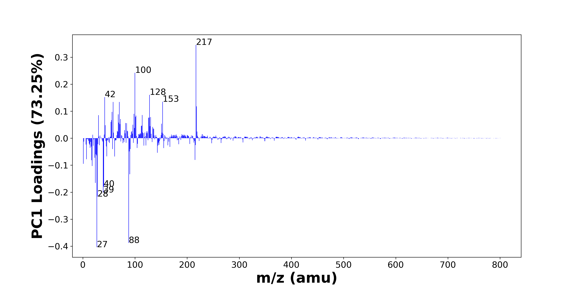

High score samples contain more:

* m/z 217 (C15H21O+, C14H19NO+, C11H21O4+), m/z 100 (C4H8N2O+), m/z 128 (C6H12N2O+), m/z 42 (C2H4N+), m/z 153 (C10H17O+), m/z 58 (C3H8N+, C4H10+), m/z 70 (C4H8N+, C3H6N2+), m/z 218 (C11H24NO3+), m/z 56 (C3H6N+, 56Fe+), m/z 98 (C4H6N2O+), m/z 68 (C4H6N+), m/z 114 (), m/z 30 (CH4N+, 30Si+), m/z 102 (C6H16N+), m/z 101 (), m/z 130 (), m/z 127 (), m/z 126 (C8H16N+), m/z 72 (C3H6NO+, C4H10N+, Si2O+, FeO+), m/z 55 (C3H5N+, C2H3N2+, C4H7+)
* Nitrogen-containing organics

Low score samples contain more:

* m/z 27 (Al+, C2H3+), m/z 88 (C3H8N2O+, C4H10NO+), m/z 28 (CH2N+, Si+), m/z 39 (K+), m/z 40 (Ca+), m/z 24 (Mg+), m/z 90 (C3H10N2O+), m/z 18 (NH4+), m/z 1 (H+), m/z 17 (NH3+, OH+), m/z 215 (), m/z 7 (Li+), m/z 23 (Na+), m/z 61 (), m/z 46 (Na2+, C2H8N+), m/z 26 (26Mg+), m/z 25 (MgH+, 25Mg+), m/z 143 (), m/z 89 (), m/z 57 (CaOH+, C4H9+)
* Hydrocarbons

# Positive ion spectra, top positive loadings -- PC1

|  |  |  |  |  |  |  |  |  |
| --- | --- | --- | --- | --- | --- | --- | --- | --- |
| + Loading No. | Unit Mass | Document Mass | Initial Peak Assignment | Initial Probabilities | Measured Mass | Peak Assignment (Qualified) | Updated Peak Assignment (from Document Mass) | Updated Document Mass |
| 1 | 217 | 217.1587 217.1461 217.1434 | C15H21O+ C14H19NO+ C11H21O4+ | 0.353 0.326 0.321 | 217.1564 | C15H21O+ C14H19NO+ C11H21O4+ |  |  |
| 2 | 100 | 100.0631 | C4H8N2O+ | 1.0 | 100.0669 | C4H8N2O+ |  |  |
| 3 | 128 | 128.0944 | C6H12N2O+ | 1.0 | 128.0915 | C6H12N2O+ |  |  |
| 4 | 42 | 42.0338 | C2H4N+ | 1.0 | 42.0351 | C2H4N+ |  |  |
| 5 | 153 | 153.1274 | C10H17O+ | 1.0 | 153.1137 | C10H17O+ |  |  |
| 6 | 58 | 58.0651 58.0777 | C3H8N+ C4H10+ | 0.52 0.48 | 58.0593 | C3H8N+ C4H10+ |  |  |
| 7 | 70 | 70.0652 70.0525 | C4H8N+ C3H6N2+ | 0.504 0.496 | 70.0575 | C4H8N+ C3H6N2+ |  |  |
| 8 | 218 | 218.1751 | C11H24NO3+ | 1.0 | 218.1543 | C11H24NO3+ |  |  |
| 9 | 56 | 56.0495 55.9344 | C3H6N+ 56Fe+ | 0.684 0.316 | 56.0438 | C3H6N+ 56Fe+ |  |  |
| 10 | 98 | 98.0475 | C4H6N2O+ | 1.0 | 98.0485 | C4H6N2O+ |  |  |
| 11 | 68 | 68.0495 | C4H6N+ | 1.0 |  |  |  |  |
| 12 | 114 |  |  |  |  |  |  |  |
| 13 | 30 | 30.0339 29.9732 | CH4N+ 30Si+ | 0.591 0.409 | 30.0327 | CH4N+ 30Si+ |  |  |
| 14 | 102 | 102.1277 | C6H16N+ | 1.0 |  |  |  |  |
| 15 | 101 |  |  |  |  |  |  |  |
| 16 | 130 |  |  |  |  |  |  |  |
| 17 | 127 |  |  |  |  |  |  |  |
| 18 | 126 | 126.1277 | C8H16N+ | 1.0 |  |  |  |  |
| 19 | 72 | 72.044 72.0808 71.9482 71.9293 | C3H6NO+ C4H10N+ Si2O+ FeO+ | 0.369 0.314 0.173 0.143 |  |  |  |  |
| 20 | 55 | 55.0417 55.0291 55.0543 | C3H5N+ C2H3N2+ C4H7+ | 0.348 0.329 0.322 | 55.0348 55.0478 | C3H5N+ C2H3N2+ C4H7+ |  |  |

Note: Highlight colors in the qualified peak assignment column represent the error relative to the measured mass(es) in that row. Green signifies an error < 100ppm, yellow an error from 100 to 200ppm, and red an error > 200ppm.

# Positive ion spectra, top negative loadings -- PC1

|  |  |  |  |  |  |  |  |  |
| --- | --- | --- | --- | --- | --- | --- | --- | --- |
| - Loading No. | Unit Mass | Document Mass | Initial Peak Assignment | Initial Probabilities | Measured Mass | Peak Assignment (Qualified) | Updated Peak Assignment (from Document Mass) | Updated Document Mass |
| 1 | 27 | 26.981 27.023 | Al+ C2H3+ | 0.57 0.43 | 26.9803 | Al+ C2H3+ |  |  |
| 2 | 88 | 88.0631 88.0757 | C3H8N2O+ C4H10NO+ | 0.52 0.48 | 88.0651 | C3H8N2O+ C4H10NO+ |  |  |
| 3 | 28 | 28.0182 27.9764 | CH2N+ Si+ | 0.542 0.458 | 27.9745 28.0164 | CH2N+ Si+ |  |  |
| 4 | 39 | 38.9632 | K+ | 1.0 | 38.9610 | K+ |  |  |
| 5 | 40 | 39.962 | Ca+ | 1.0 | 39.9500 | Ca+ |  |  |
| 6 | 24 | 23.9845 | Mg+ | 1.0 | 23.98726 | Mg+ |  |  |
| 7 | 90 | 90.0788 | C3H10N2O+ | 1.0 | 90.0795 | C3H10N2O+ |  |  |
| 8 | 18 | 18.0339 | NH4+ | 1.0 | 18.0331 | NH4+ |  |  |
| 9 | 1 | 1.0073 | H+ | 1.0 | 1.0073 | H+ |  |  |
| 10 | 17 | 17.026 17.0022 | NH3+ OH+ | 0.519 0.481 | 17.0249 | NH3+ OH+ |  |  |
| 11 | 215 |  |  |  |  |  |  |  |
| 12 | 7 | 7.0155 | Li+ | 1.0 | 7.0156 | Li+ |  |  |
| 13 | 23 | 22.9892 | Na+ | 1.0 | 22.9924 | Na+ |  |  |
| 14 | 61 |  |  |  |  |  |  |  |
| 15 | 46 | 45.979 46.0652 | Na2+ C2H8N+ | 0.508 0.492 |  |  |  |  |
| 16 | 26 | 25.982 | 26Mg+ | 1.0 |  |  |  |  |
| 17 | 25 | 24.9923 24.9853 | MgH+ 25Mg+ | 0.504 0.496 | 24.9901 24.9830 | MgH+ 25Mg+ |  |  |
| 18 | 143 |  |  |  |  |  |  |  |
| 19 | 89 |  |  |  |  |  |  |  |
| 20 | 57 | 56.9648 57.0699 | CaOH+ C4H9+ | 0.678 0.322 |  |  |  |  |

Note: Highlight colors in the qualified peak assignment column represent the error relative to the measured mass(es) in that row. Green signifies an error < 100ppm, yellow an error from 100 to 200ppm, and red an error > 200ppm.

# Positive ion spectra, molecular information from PC1 loadings plot

* The major positive PC1 loadings are m/z 217 (C15H21O+, C14H19NO+, C11H21O4+), m/z 100 (C4H8N2O+), m/z 128 (C6H12N2O+), m/z 42 (C2H4N+), m/z 153 (C10H17O+), m/z 58 (C3H8N+, C4H10+), m/z 70 (C4H8N+, C3H6N2+), m/z 218 (C11H24NO3+), m/z 56 (C3H6N+, 56Fe+), m/z 98 (C4H6N2O+), m/z 68 (C4H6N+), m/z 114 (), m/z 30 (CH4N+, 30Si+), m/z 102 (C6H16N+), m/z 101 (), m/z 130 (), m/z 127 (), m/z 126 (C8H16N+), m/z 72 (C3H6NO+, C4H10N+, Si2O+, FeO+), m/z 55 (C3H5N+, C2H3N2+, C4H7+), indicating they are more observed in high PC1 score samples.
* The major negative PC1 loadings are m/z 27 (Al+, C2H3+), m/z 88 (C3H8N2O+, C4H10NO+), m/z 28 (CH2N+, Si+), m/z 39 (K+), m/z 40 (Ca+), m/z 24 (Mg+), m/z 90 (C3H10N2O+), m/z 18 (NH4+), m/z 1 (H+), m/z 17 (NH3+, OH+), m/z 215 (), m/z 7 (Li+), m/z 23 (Na+), m/z 61 (), m/z 46 (Na2+, C2H8N+), m/z 26 (26Mg+), m/z 25 (MgH+, 25Mg+), m/z 143 (), m/z 89 (), m/z 57 (CaOH+, C4H9+), indicating they are more observed in low PC1 score samples.
* Nitrogen-containing organics signals, such as m/z 30 (CH4N+, 30Si+), m/z 70 (C4H8N+, C3H6N2+), are mostly found in positive loadings, indicating that high PC1 score samples contain more Nitrogen-containing organics.
* Hydrocarbons signals, such as m/z 27 (Al+, C2H3+), m/z 57 (CaOH+, C4H9+), are mostly found in negative loadings, indicating that low PC1 score samples contain more Hydrocarbons.

# Positive ion spectra, PCA analysis results -- PC2

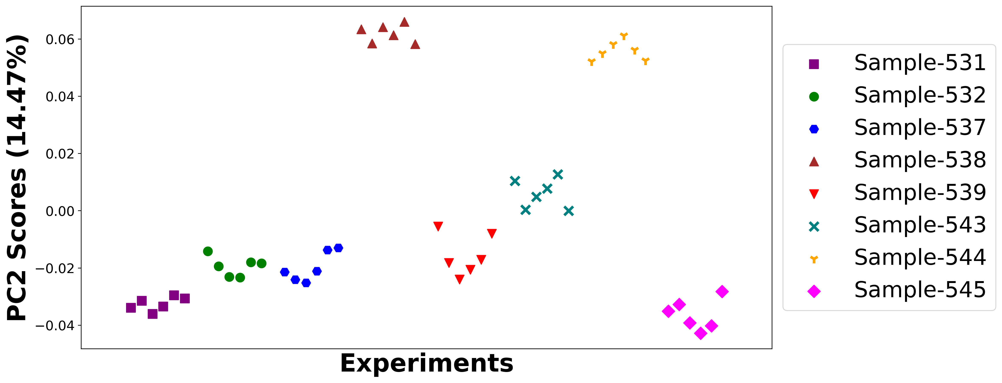

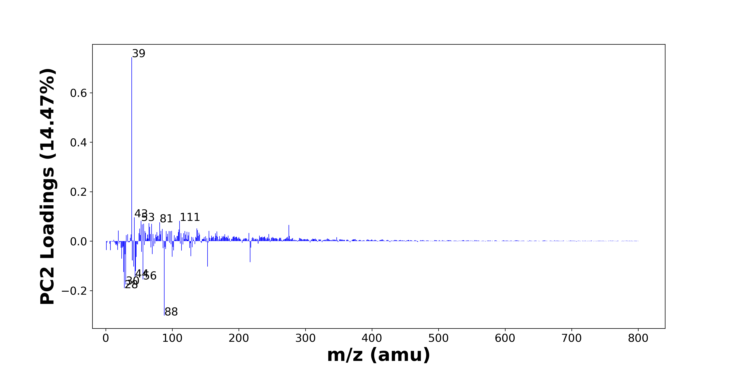

High score samples contain more:

* m/z 39 (K+), m/z 43 (C2H5N+, C3H7+, C2H3O+), m/z 53 (C3H3N+, C4H5+), m/z 111 (CH3SO4+, SiH3O5+), m/z 81 (C5H5O+), m/z 65 (C4H3N+, HSO2+), m/z 57 (CaOH+, C4H9+), m/z 69 (C3H5N2+), m/z 55 (C3H5N+, C2H3N2+, C4H7+), m/z 275 (C17H23O3+), m/z 66 (CaCN+), m/z 137 (), m/z 51 (C4H3+), m/z 85 (Na3O+, NaSNO+), m/z 110 (), m/z 138 (), m/z 19 (OH3+), m/z 83 (C5H9N+), m/z 155 (), m/z 99 (H3SO4+)
* Hydrocarbons

Low score samples contain more:

* m/z 88 (C3H8N2O+, C4H10NO+), m/z 28 (CH2N+, Si+), m/z 30 (CH4N+, 30Si+), m/z 56 (C3H6N+, 56Fe+), m/z 44 (C2H6N+, C3H8+), m/z 27 (Al+, C2H3+), m/z 45 (C2H5O+, SiOH+), m/z 42 (C2H4N+), m/z 153 (C10H17O+), m/z 217 (C15H21O+, C14H19NO+, C11H21O4+), m/z 40 (Ca+), m/z 24 (Mg+), m/z 46 (Na2+, C2H8N+), m/z 100 (C4H8N2O+), m/z 128 (C6H12N2O+), m/z 29 (C2H5+, 29Si+), m/z 70 (C4H8N+, C3H6N2+), m/z 54 (), m/z 114 (), m/z 102 (C6H16N+)
* Nitrogen-containing organics

# Positive ion spectra, top positive loadings -- PC2

|  |  |  |  |  |  |  |  |  |
| --- | --- | --- | --- | --- | --- | --- | --- | --- |
| + Loading No. | Unit Mass | Document Mass | Initial Peak Assignment | Initial Probabilities | Measured Mass | Peak Assignment (Qualified) | Updated Peak Assignment (from Document Mass) | Updated Document Mass |
| 1 | 39 | 38.9632 | K+ | 1.0 | 38.9610 | K+ |  |  |
| 2 | 43 | 43.0417 43.0543 43.0178 | C2H5N+ C3H7+ C2H3O+ | 0.357 0.33 0.313 | 43.0175 43.0419 43.0540 | C2H5N+ C3H7+ C2H3O+ |  |  |
| 3 | 53 | 53.026 53.0386 | C3H3N+ C4H5+ | 0.507 0.493 | 53.0319 | C3H3N+ C4H5+ |  |  |
| 4 | 111 | 110.9747 110.9744 | CH3SO4+ SiH3O5+ | 0.501 0.499 | 110.9640 | CH3SO4+ SiH3O5+ |  |  |
| 5 | 81 | 81.0335 | C5H5O+ | 1.0 | 81.0373 | C5H5O+ |  |  |
| 6 | 65 | 65.026 64.9692 | C4H3N+ HSO2+ | 0.543 0.457 | 64.9631 65.0291 | C4H3N+ HSO2+ |  |  |
| 7 | 57 | 56.9648 57.0699 | CaOH+ C4H9+ | 0.678 0.322 |  |  |  |  |
| 8 | 69 | 69.0447 | C3H5N2+ | 1.0 | 69.4093 | C3H5N2+ |  |  |
| 9 | 55 | 55.0417 55.0291 55.0543 | C3H5N+ C2H3N2+ C4H7+ | 0.348 0.329 0.322 | 55.0348 55.0478 | C3H5N+ C2H3N2+ C4H7+ |  |  |
| 10 | 275 | 275.1642 | C17H23O3+ | 1.0 | 275.1458 | C17H23O3+ |  |  |
| 11 | 66 | 65.9651 | CaCN+ | 1.0 |  |  |  |  |
| 12 | 137 |  |  |  |  |  |  |  |
| 13 | 51 | 51.0229 | C4H3+ | 1.0 | 51.0164 | C4H3+ |  |  |
| 14 | 85 | 84.9637 84.9593 | Na3O+ NaSNO+ | 0.51 0.49 |  |  |  |  |
| 15 | 110 |  |  |  |  |  |  |  |
| 16 | 138 |  |  |  |  |  |  |  |
| 17 | 19 | 19.0179 | OH3+ | 1.0 |  |  |  |  |
| 18 | 83 | 83.073 | C5H9N+ | 1.0 | 83.0716 | C5H9N+ |  |  |
| 19 | 155 |  |  |  |  |  |  |  |
| 20 | 99 | 98.9747 | H3SO4+ | 1.0 |  |  |  |  |

Note: Highlight colors in the qualified peak assignment column represent the error relative to the measured mass(es) in that row. Green signifies an error < 100ppm, yellow an error from 100 to 200ppm, and red an error > 200ppm.

# Positive ion spectra, top negative loadings -- PC2

|  |  |  |  |  |  |  |  |  |
| --- | --- | --- | --- | --- | --- | --- | --- | --- |
| - Loading No. | Unit Mass | Document Mass | Initial Peak Assignment | Initial Probabilities | Measured Mass | Peak Assignment (Qualified) | Updated Peak Assignment (from Document Mass) | Updated Document Mass |
| 1 | 88 | 88.0631 88.0757 | C3H8N2O+ C4H10NO+ | 0.52 0.48 | 88.0651 | C3H8N2O+ C4H10NO+ |  |  |
| 2 | 28 | 28.0182 27.9764 | CH2N+ Si+ | 0.542 0.458 | 27.9745 28.0164 | CH2N+ Si+ |  |  |
| 3 | 30 | 30.0339 29.9732 | CH4N+ 30Si+ | 0.591 0.409 | 30.0327 | CH4N+ 30Si+ |  |  |
| 4 | 56 | 56.0495 55.9344 | C3H6N+ 56Fe+ | 0.684 0.316 | 56.0438 | C3H6N+ 56Fe+ |  |  |
| 5 | 44 | 44.0495 44.0621 | C2H6N+ C3H8+ | 0.518 0.482 | 44.0483 | C2H6N+ C3H8+ |  |  |
| 6 | 27 | 26.981 27.023 | Al+ C2H3+ | 0.57 0.43 | 26.9803 | Al+ C2H3+ |  |  |
| 7 | 45 | 45.0335 44.9792 | C2H5O+ SiOH+ | 0.58 0.42 | 45.0295 44.9744 | C2H5O+ SiOH+ |  |  |
| 8 | 42 | 42.0338 | C2H4N+ | 1.0 | 42.0351 | C2H4N+ |  |  |
| 9 | 153 | 153.1274 | C10H17O+ | 1.0 | 153.1137 | C10H17O+ |  |  |
| 10 | 217 | 217.1587 217.1461 217.1434 | C15H21O+ C14H19NO+ C11H21O4+ | 0.353 0.326 0.321 | 217.1564 | C15H21O+ C14H19NO+ C11H21O4+ |  |  |
| 11 | 40 | 39.962 | Ca+ | 1.0 | 39.9500 | Ca+ |  |  |
| 12 | 24 | 23.9845 | Mg+ | 1.0 | 23.98726 | Mg+ |  |  |
| 13 | 46 | 45.979 46.0652 | Na2+ C2H8N+ | 0.508 0.492 |  |  |  |  |
| 14 | 100 | 100.0631 | C4H8N2O+ | 1.0 | 100.0669 | C4H8N2O+ |  |  |
| 15 | 128 | 128.0944 | C6H12N2O+ | 1.0 | 128.0915 | C6H12N2O+ |  |  |
| 16 | 29 | 29.0386 28.9759 | C2H5+ 29Si+ | 0.579 0.421 |  |  |  |  |
| 17 | 70 | 70.0652 70.0525 | C4H8N+ C3H6N2+ | 0.504 0.496 | 70.0575 | C4H8N+ C3H6N2+ |  |  |
| 18 | 54 |  |  |  |  |  |  |  |
| 19 | 114 |  |  |  |  |  |  |  |
| 20 | 102 | 102.1277 | C6H16N+ | 1.0 |  |  |  |  |

Note: Highlight colors in the qualified peak assignment column represent the error relative to the measured mass(es) in that row. Green signifies an error < 100ppm, yellow an error from 100 to 200ppm, and red an error > 200ppm.

# Positive ion spectra, molecular information from PC2 loadings plot

* The major positive PC2 loadings are m/z 39 (K+), m/z 43 (C2H5N+, C3H7+, C2H3O+), m/z 53 (C3H3N+, C4H5+), m/z 111 (CH3SO4+, SiH3O5+), m/z 81 (C5H5O+), m/z 65 (C4H3N+, HSO2+), m/z 57 (CaOH+, C4H9+), m/z 69 (C3H5N2+), m/z 55 (C3H5N+, C2H3N2+, C4H7+), m/z 275 (C17H23O3+), m/z 66 (CaCN+), m/z 137 (), m/z 51 (C4H3+), m/z 85 (Na3O+, NaSNO+), m/z 110 (), m/z 138 (), m/z 19 (OH3+), m/z 83 (C5H9N+), m/z 155 (), m/z 99 (H3SO4+), indicating they are more observed in high PC2 score samples.
* The major negative PC2 loadings are m/z 88 (C3H8N2O+, C4H10NO+), m/z 28 (CH2N+, Si+), m/z 30 (CH4N+, 30Si+), m/z 56 (C3H6N+, 56Fe+), m/z 44 (C2H6N+, C3H8+), m/z 27 (Al+, C2H3+), m/z 45 (C2H5O+, SiOH+), m/z 42 (C2H4N+), m/z 153 (C10H17O+), m/z 217 (C15H21O+, C14H19NO+, C11H21O4+), m/z 40 (Ca+), m/z 24 (Mg+), m/z 46 (Na2+, C2H8N+), m/z 100 (C4H8N2O+), m/z 128 (C6H12N2O+), m/z 29 (C2H5+, 29Si+), m/z 70 (C4H8N+, C3H6N2+), m/z 54 (), m/z 114 (), m/z 102 (C6H16N+), indicating they are more observed in low PC2 score samples.
* Hydrocarbons signals, such as m/z 43 (C2H5N+, C3H7+, C2H3O+), m/z 55 (C3H5N+, C2H3N2+, C4H7+), m/z 57 (CaOH+, C4H9+), are mostly found in positive loadings, indicating that high PC2 score samples contain more Hydrocarbons.
* Nitrogen-containing organics signals, such as m/z 30 (CH4N+, 30Si+), m/z 44 (C2H6N+, C3H8+), m/z 70 (C4H8N+, C3H6N2+), are mostly found in negative loadings, indicating that low PC2 score samples contain more Nitrogen-containing organics.

# Positive ion spectra, PCA analysis results -- PC3

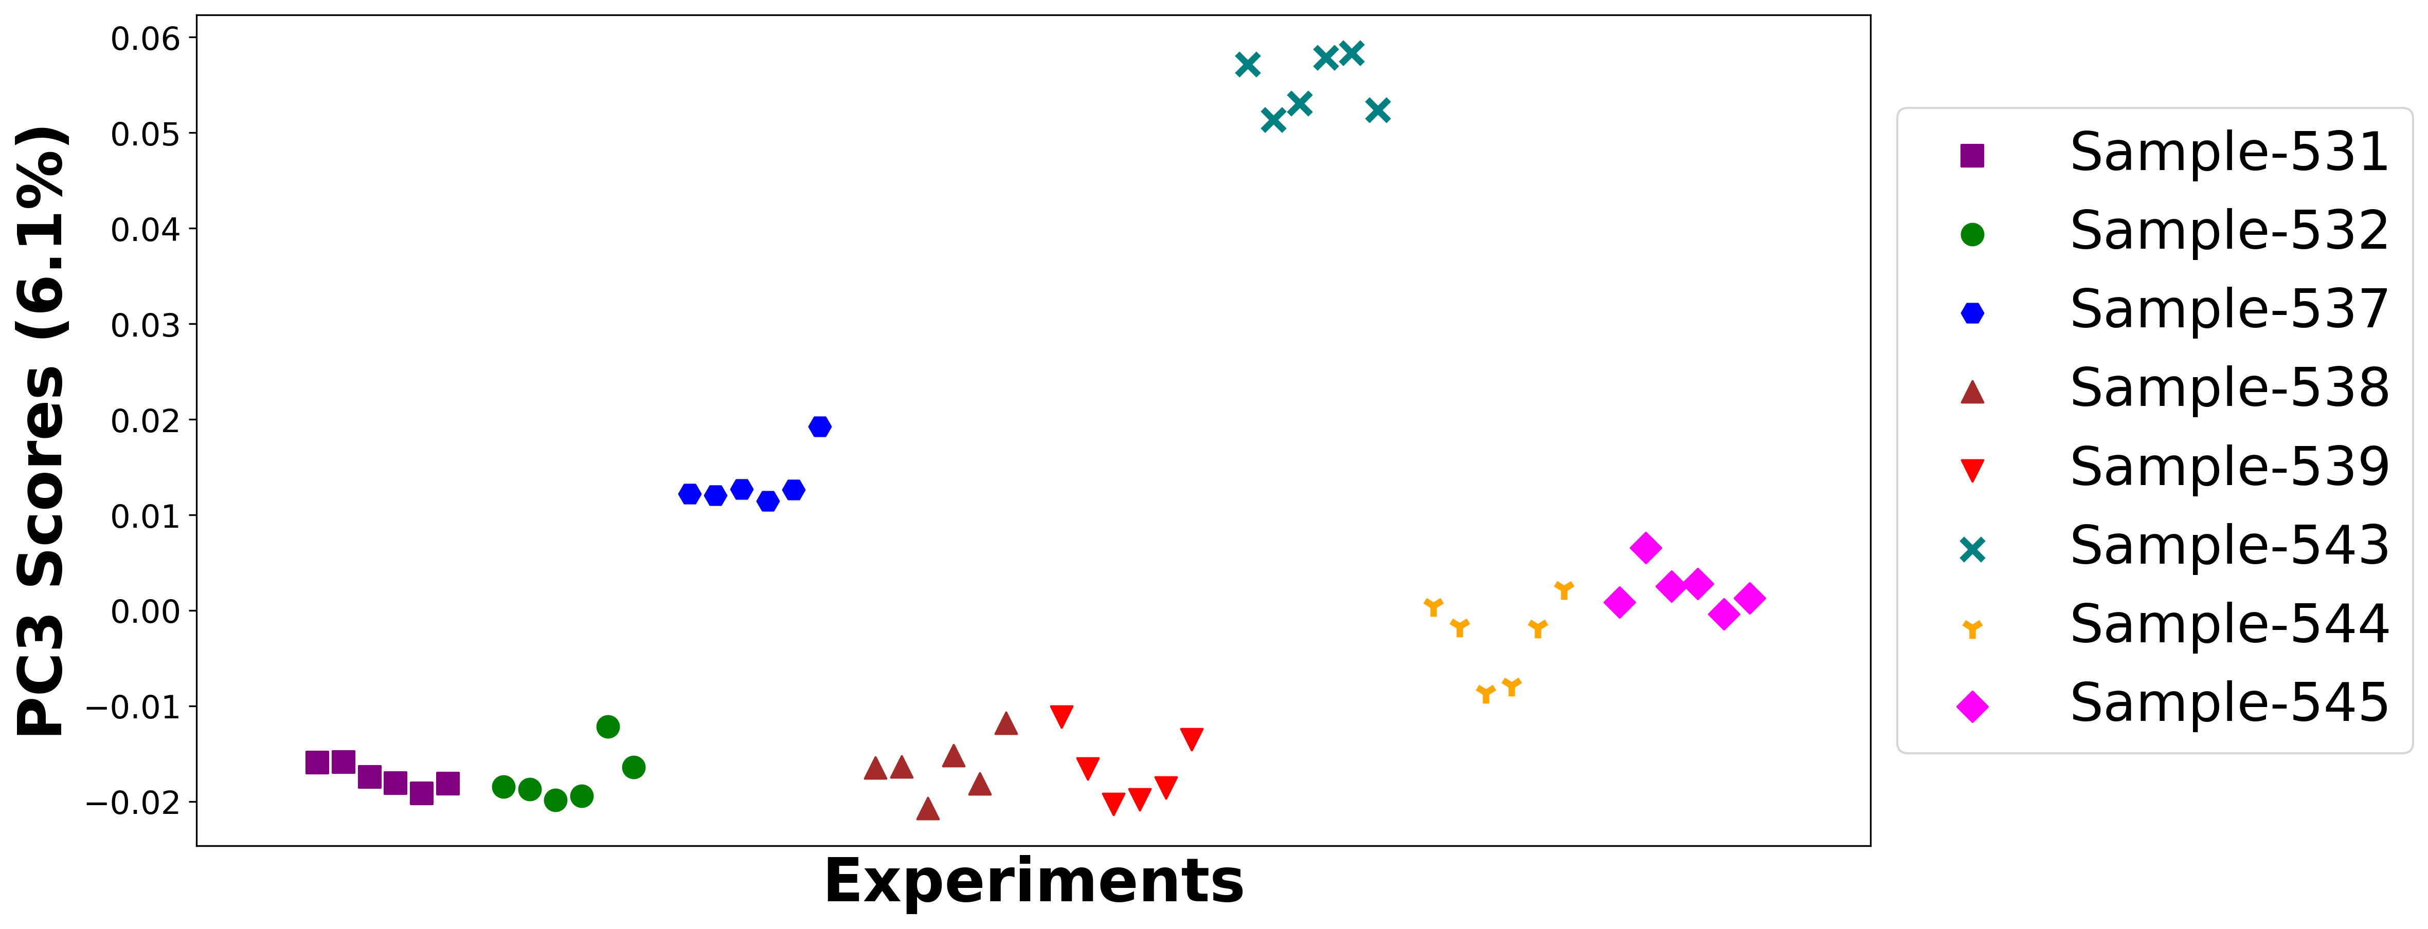

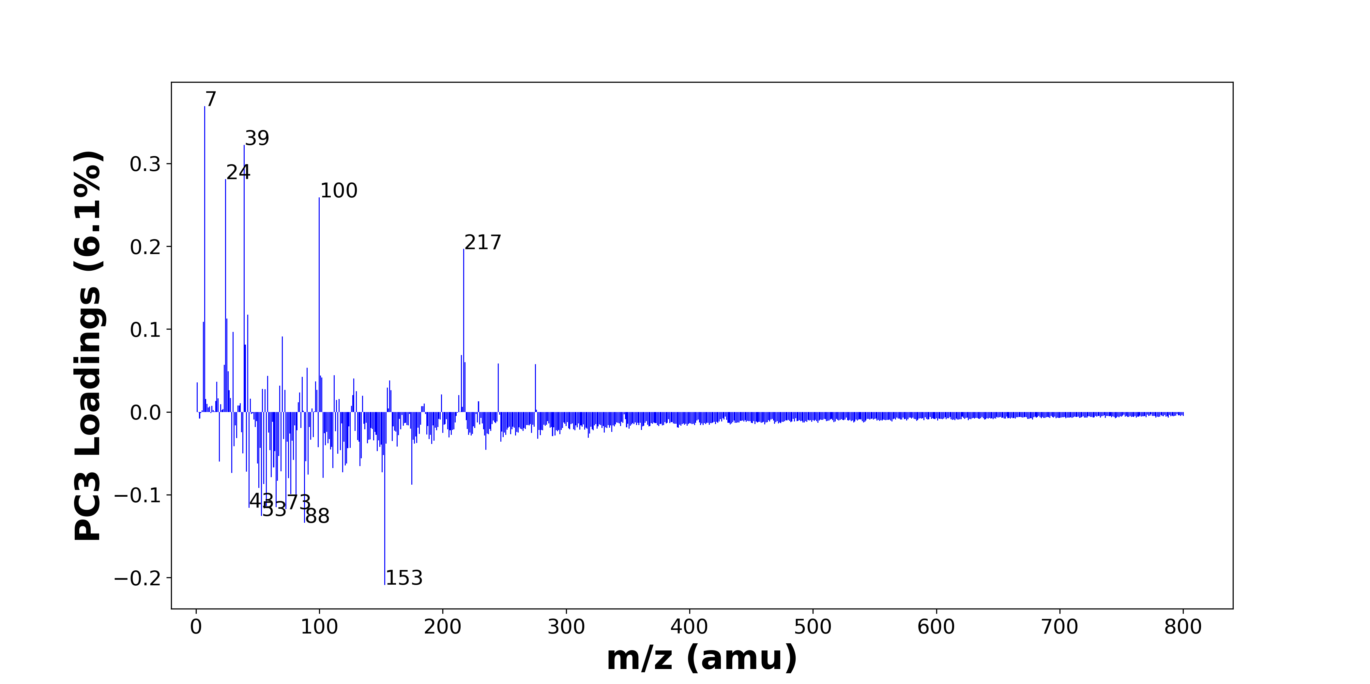

High score samples contain more:

* m/z 7 (Li+), m/z 39 (K+), m/z 24 (Mg+), m/z 100 (C4H8N2O+), m/z 217 (C15H21O+, C14H19NO+, C11H21O4+), m/z 42 (C2H4N+), m/z 25 (MgH+, 25Mg+), m/z 6 (6Li+), m/z 30 (CH4N+, 30Si+), m/z 70 (C4H8N+, C3H6N2+), m/z 40 (Ca+), m/z 215 (), m/z 218 (C11H24NO3+), m/z 245 (), m/z 275 (C17H23O3+), m/z 23 (Na+), m/z 90 (C3H10N2O+), m/z 26 (26Mg+), m/z 112 (Ca2O2+), m/z 101 ()
* Nitrogen-containing organics

Low score samples contain more:

* m/z 153 (C10H17O+), m/z 88 (C3H8N2O+, C4H10NO+), m/z 53 (C3H3N+, C4H5+), m/z 73 (SiC3H9+, FeOH+), m/z 43 (C2H5N+, C3H7+, C2H3O+), m/z 65 (C4H3N+, HSO2+), m/z 57 (CaOH+, C4H9+), m/z 81 (C5H5O+), m/z 77 (C5H3N+, C6H5+), m/z 51 (C4H3+), m/z 175 (Ca2PO4+, K2SO4H+), m/z 55 (C3H5N+, C2H3N2+, C4H7+), m/z 66 (CaCN+), m/z 75 (), m/z 103 (), m/z 61 (), m/z 91 (C7H7+, C3H9NO2+), m/z 29 (C2H5+, 29Si+), m/z 151 (), m/z 119 ()
* Hydrocarbons, Benzene-containing organics

# Positive ion spectra, top positive loadings -- PC3

|  |  |  |  |  |  |  |  |  |
| --- | --- | --- | --- | --- | --- | --- | --- | --- |
| + Loading No. | Unit Mass | Document Mass | Initial Peak Assignment | Initial Probabilities | Measured Mass | Peak Assignment (Qualified) | Updated Peak Assignment (from Document Mass) | Updated Document Mass |
| 1 | 7 | 7.0155 | Li+ | 1.0 | 7.0156 | Li+ |  |  |
| 2 | 39 | 38.9632 | K+ | 1.0 | 38.9610 | K+ |  |  |
| 3 | 24 | 23.9845 | Mg+ | 1.0 | 23.98726 | Mg+ |  |  |
| 4 | 100 | 100.0631 | C4H8N2O+ | 1.0 | 100.0669 | C4H8N2O+ |  |  |
| 5 | 217 | 217.1587 217.1461 217.1434 | C15H21O+ C14H19NO+ C11H21O4+ | 0.353 0.326 0.321 | 217.1564 | C15H21O+ C14H19NO+ C11H21O4+ |  |  |
| 6 | 42 | 42.0338 | C2H4N+ | 1.0 | 42.0351 | C2H4N+ |  |  |
| 7 | 25 | 24.9923 24.9853 | MgH+ 25Mg+ | 0.504 0.496 | 24.9901 24.9830 | MgH+ 25Mg+ |  |  |
| 8 | 6 | 6.0146 | 6Li+ | 1.0 | 6.0147 | 6Li+ |  |  |
| 9 | 30 | 30.0339 29.9732 | CH4N+ 30Si+ | 0.591 0.409 | 30.0327 | CH4N+ 30Si+ |  |  |
| 10 | 70 | 70.0652 70.0525 | C4H8N+ C3H6N2+ | 0.504 0.496 | 70.0575 | C4H8N+ C3H6N2+ |  |  |
| 11 | 40 | 39.962 | Ca+ | 1.0 | 39.9500 | Ca+ |  |  |
| 12 | 215 |  |  |  |  |  |  |  |
| 13 | 218 | 218.1751 | C11H24NO3+ | 1.0 | 218.1543 | C11H24NO3+ |  |  |
| 14 | 245 |  |  |  |  |  |  |  |
| 15 | 275 | 275.1642 | C17H23O3+ | 1.0 | 275.1458 | C17H23O3+ |  |  |
| 16 | 23 | 22.9892 | Na+ | 1.0 | 22.9924 | Na+ |  |  |
| 17 | 90 | 90.0788 | C3H10N2O+ | 1.0 | 90.0795 | C3H10N2O+ |  |  |
| 18 | 26 | 25.982 | 26Mg+ | 1.0 |  |  |  |  |
| 19 | 112 | 111.9145 | Ca2O2+ | 1.0 |  |  |  |  |
| 20 | 101 |  |  |  |  |  |  |  |

Note: Highlight colors in the qualified peak assignment column represent the error relative to the measured mass(es) in that row. Green signifies an error < 100ppm, yellow an error from 100 to 200ppm, and red an error > 200ppm.

# Positive ion spectra, top negative loadings -- PC3

|  |  |  |  |  |  |  |  |  |
| --- | --- | --- | --- | --- | --- | --- | --- | --- |
| - Loading No. | Unit Mass | Document Mass | Initial Peak Assignment | Initial Probabilities | Measured Mass | Peak Assignment (Qualified) | Updated Peak Assignment (from Document Mass) | Updated Document Mass |
| 1 | 153 | 153.1274 | C10H17O+ | 1.0 | 153.1137 | C10H17O+ |  |  |
| 2 | 88 | 88.0631 88.0757 | C3H8N2O+ C4H10NO+ | 0.52 0.48 | 88.0651 | C3H8N2O+ C4H10NO+ |  |  |
| 3 | 53 | 53.026 53.0386 | C3H3N+ C4H5+ | 0.507 0.493 | 53.0319 | C3H3N+ C4H5+ |  |  |
| 4 | 73 | 73.0469 72.9371 | SiC3H9+ FeOH+ | 0.646 0.354 |  |  |  |  |
| 5 | 43 | 43.0417 43.0543 43.0178 | C2H5N+ C3H7+ C2H3O+ | 0.357 0.33 0.313 | 43.0175 43.0419 43.0540 | C2H5N+ C3H7+ C2H3O+ |  |  |
| 6 | 65 | 65.026 64.9692 | C4H3N+ HSO2+ | 0.543 0.457 | 64.9631 65.0291 | C4H3N+ HSO2+ |  |  |
| 7 | 57 | 56.9648 57.0699 | CaOH+ C4H9+ | 0.678 0.322 |  |  |  |  |
| 8 | 81 | 81.0335 | C5H5O+ | 1.0 | 81.0373 | C5H5O+ |  |  |
| 9 | 77 | 77.026 77.0386 | C5H3N+ C6H5+ | 0.52 0.48 | 77.0279 | C5H3N+ C6H5+ |  |  |
| 10 | 51 | 51.0229 | C4H3+ | 1.0 | 51.0164 | C4H3+ |  |  |
| 11 | 175 | 174.8781 174.8864 | Ca2PO4+ K2SO4H+ | 0.514 0.486 |  |  |  |  |
| 12 | 55 | 55.0417 55.0291 55.0543 | C3H5N+ C2H3N2+ C4H7+ | 0.348 0.329 0.322 | 55.0348 55.0478 | C3H5N+ C2H3N2+ C4H7+ |  |  |
| 13 | 66 | 65.9651 | CaCN+ | 1.0 |  |  |  |  |
| 14 | 75 |  |  |  |  |  |  |  |
| 15 | 103 |  |  |  |  |  |  |  |
| 16 | 61 |  |  |  |  |  |  |  |
| 17 | 91 | 91.0543 91.0628 | C7H7+ C3H9NO2+ | 0.514 0.486 |  |  |  |  |
| 18 | 29 | 29.0386 28.9759 | C2H5+ 29Si+ | 0.579 0.421 |  |  |  |  |
| 19 | 151 |  |  |  |  |  |  |  |
| 20 | 119 |  |  |  |  |  |  |  |

Note: Highlight colors in the qualified peak assignment column represent the error relative to the measured mass(es) in that row. Green signifies an error < 100ppm, yellow an error from 100 to 200ppm, and red an error > 200ppm.

# Positive ion spectra, molecular information from PC3 loadings plot

* The major positive PC3 loadings are m/z 7 (Li+), m/z 39 (K+), m/z 24 (Mg+), m/z 100 (C4H8N2O+), m/z 217 (C15H21O+, C14H19NO+, C11H21O4+), m/z 42 (C2H4N+), m/z 25 (MgH+, 25Mg+), m/z 6 (6Li+), m/z 30 (CH4N+, 30Si+), m/z 70 (C4H8N+, C3H6N2+), m/z 40 (Ca+), m/z 215 (), m/z 218 (C11H24NO3+), m/z 245 (), m/z 275 (C17H23O3+), m/z 23 (Na+), m/z 90 (C3H10N2O+), m/z 26 (26Mg+), m/z 112 (Ca2O2+), m/z 101 (), indicating they are more observed in high PC3 score samples.
* The major negative PC3 loadings are m/z 153 (C10H17O+), m/z 88 (C3H8N2O+, C4H10NO+), m/z 53 (C3H3N+, C4H5+), m/z 73 (SiC3H9+, FeOH+), m/z 43 (C2H5N+, C3H7+, C2H3O+), m/z 65 (C4H3N+, HSO2+), m/z 57 (CaOH+, C4H9+), m/z 81 (C5H5O+), m/z 77 (C5H3N+, C6H5+), m/z 51 (C4H3+), m/z 175 (Ca2PO4+, K2SO4H+), m/z 55 (C3H5N+, C2H3N2+, C4H7+), m/z 66 (CaCN+), m/z 75 (), m/z 103 (), m/z 61 (), m/z 91 (C7H7+, C3H9NO2+), m/z 29 (C2H5+, 29Si+), m/z 151 (), m/z 119 (), indicating they are more observed in low PC3 score samples.
* Nitrogen-containing organics signals, such as m/z 30 (CH4N+, 30Si+), m/z 70 (C4H8N+, C3H6N2+), are mostly found in positive loadings, indicating that high PC3 score samples contain more Nitrogen-containing organics.
* Hydrocarbons signals, such as m/z 29 (C2H5+, 29Si+), m/z 43 (C2H5N+, C3H7+, C2H3O+), m/z 55 (C3H5N+, C2H3N2+, C4H7+), m/z 57 (CaOH+, C4H9+), are mostly found in negative loadings, indicating that low PC3 score samples contain more Hydrocarbons.
* Benzene-containing organics signals, such as m/z 91 (C7H7+, C3H9NO2+), m/z 77 (C5H3N+, C6H5+), are mostly found in negative loadings, indicating that low PC3 score samples contain more Benzene-containing organics.

# Positive ion spectra, PCA analysis results -- PC4

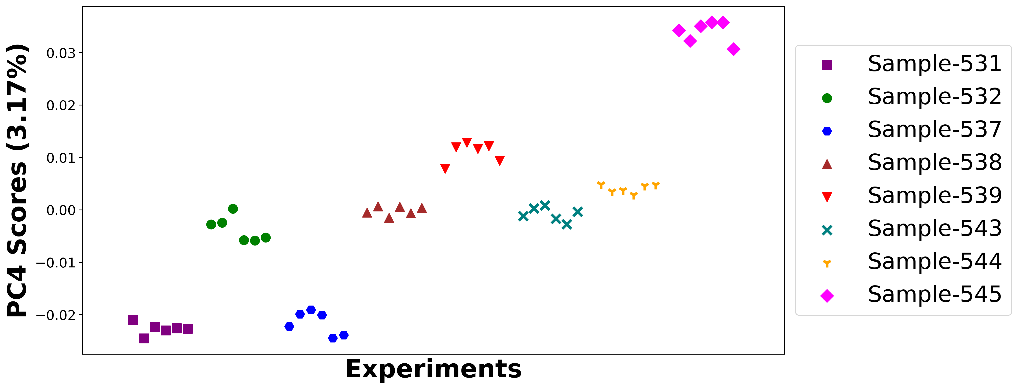

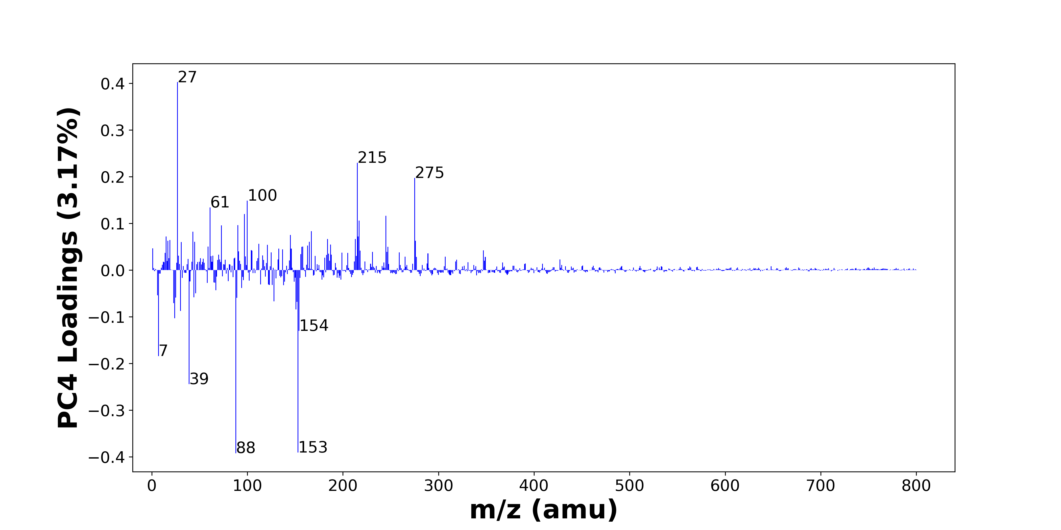

High score samples contain more:

* m/z 27 (Al+, C2H3+), m/z 215 (), m/z 275 (C17H23O3+), m/z 100 (C4H8N2O+), m/z 61 (), m/z 97 (), m/z 245 (), m/z 217 (C15H21O+, C14H19NO+, C11H21O4+), m/z 90 (C3H10N2O+), m/z 73 (SiC3H9+, FeOH+), m/z 167 (), m/z 43 (C2H5N+, C3H7+, C2H3O+), m/z 145 (), m/z 15 (CH3+), m/z 216 (), m/z 184 (), m/z 213 (), m/z 19 (OH3+), m/z 276 (), m/z 17 (NH3+, OH+)
* Hydrocarbons, PDMS

Low score samples contain more:

* m/z 88 (C3H8N2O+, C4H10NO+), m/z 153 (C10H17O+), m/z 39 (K+), m/z 7 (Li+), m/z 154 (), m/z 24 (Mg+), m/z 30 (CH4N+, 30Si+), m/z 151 (), m/z 23 (Na+), m/z 152 (), m/z 128 (C6H12N2O+), m/z 89 (), m/z 25 (MgH+, 25Mg+), m/z 44 (C2H6N+, C3H8+), m/z 6 (6Li+), m/z 46 (Na2+, C2H8N+), m/z 67 (), m/z 94 (), m/z 138 (), m/z 123 ()
* Nitrogen-containing organics

# Positive ion spectra, top positive loadings -- PC4

|  |  |  |  |  |  |  |  |  |
| --- | --- | --- | --- | --- | --- | --- | --- | --- |
| + Loading No. | Unit Mass | Document Mass | Initial Peak Assignment | Initial Probabilities | Measured Mass | Peak Assignment (Qualified) | Updated Peak Assignment (from Document Mass) | Updated Document Mass |
| 1 | 27 | 26.981 27.023 | Al+ C2H3+ | 0.57 0.43 | 26.9803 | Al+ C2H3+ |  |  |
| 2 | 215 |  |  |  |  |  |  |  |
| 3 | 275 | 275.1642 | C17H23O3+ | 1.0 | 275.1458 | C17H23O3+ |  |  |
| 4 | 100 | 100.0631 | C4H8N2O+ | 1.0 | 100.0669 | C4H8N2O+ |  |  |
| 5 | 61 |  |  |  |  |  |  |  |
| 6 | 97 |  |  |  |  |  |  |  |
| 7 | 245 |  |  |  |  |  |  |  |
| 8 | 217 | 217.1587 217.1461 217.1434 | C15H21O+ C14H19NO+ C11H21O4+ | 0.353 0.326 0.321 | 217.1564 | C15H21O+ C14H19NO+ C11H21O4+ |  |  |
| 9 | 90 | 90.0788 | C3H10N2O+ | 1.0 | 90.0795 | C3H10N2O+ |  |  |
| 10 | 73 | 73.0469 72.9371 | SiC3H9+ FeOH+ | 0.646 0.354 |  |  |  |  |
| 11 | 167 |  |  |  |  |  |  |  |
| 12 | 43 | 43.0417 43.0543 43.0178 | C2H5N+ C3H7+ C2H3O+ | 0.357 0.33 0.313 | 43.0175 43.0419 43.0540 | C2H5N+ C3H7+ C2H3O+ |  |  |
| 13 | 145 |  |  |  |  |  |  |  |
| 14 | 15 | 15.023 | CH3+ | 1.0 |  |  |  |  |
| 15 | 216 |  |  |  |  |  |  |  |
| 16 | 184 |  |  |  |  |  |  |  |
| 17 | 213 |  |  |  |  |  |  |  |
| 18 | 19 | 19.0179 | OH3+ | 1.0 |  |  |  |  |
| 19 | 276 |  |  |  |  |  |  |  |
| 20 | 17 | 17.026 17.0022 | NH3+ OH+ | 0.519 0.481 | 17.0249 | NH3+ OH+ |  |  |

Note: Highlight colors in the qualified peak assignment column represent the error relative to the measured mass(es) in that row. Green signifies an error < 100ppm, yellow an error from 100 to 200ppm, and red an error > 200ppm.

# Positive ion spectra, top negative loadings -- PC4

|  |  |  |  |  |  |  |  |  |
| --- | --- | --- | --- | --- | --- | --- | --- | --- |
| - Loading No. | Unit Mass | Document Mass | Initial Peak Assignment | Initial Probabilities | Measured Mass | Peak Assignment (Qualified) | Updated Peak Assignment (from Document Mass) | Updated Document Mass |
| 1 | 88 | 88.0631 88.0757 | C3H8N2O+ C4H10NO+ | 0.52 0.48 | 88.0651 | C3H8N2O+ C4H10NO+ |  |  |
| 2 | 153 | 153.1274 | C10H17O+ | 1.0 | 153.1137 | C10H17O+ |  |  |
| 3 | 39 | 38.9632 | K+ | 1.0 | 38.9610 | K+ |  |  |
| 4 | 7 | 7.0155 | Li+ | 1.0 | 7.0156 | Li+ |  |  |
| 5 | 154 |  |  |  |  |  |  |  |
| 6 | 24 | 23.9845 | Mg+ | 1.0 | 23.98726 | Mg+ |  |  |
| 7 | 30 | 30.0339 29.9732 | CH4N+ 30Si+ | 0.591 0.409 | 30.0327 | CH4N+ 30Si+ |  |  |
| 8 | 151 |  |  |  |  |  |  |  |
| 9 | 23 | 22.9892 | Na+ | 1.0 | 22.9924 | Na+ |  |  |
| 10 | 152 |  |  |  |  |  |  |  |
| 11 | 128 | 128.0944 | C6H12N2O+ | 1.0 | 128.0915 | C6H12N2O+ |  |  |
| 12 | 89 |  |  |  |  |  |  |  |
| 13 | 25 | 24.9923 24.9853 | MgH+ 25Mg+ | 0.504 0.496 | 24.9901 24.9830 | MgH+ 25Mg+ |  |  |
| 14 | 44 | 44.0495 44.0621 | C2H6N+ C3H8+ | 0.518 0.482 | 44.0483 | C2H6N+ C3H8+ |  |  |
| 15 | 6 | 6.0146 | 6Li+ | 1.0 | 6.0147 | 6Li+ |  |  |
| 16 | 46 | 45.979 46.0652 | Na2+ C2H8N+ | 0.508 0.492 |  |  |  |  |
| 17 | 67 |  |  |  |  |  |  |  |
| 18 | 94 |  |  |  |  |  |  |  |
| 19 | 138 |  |  |  |  |  |  |  |
| 20 | 123 |  |  |  |  |  |  |  |

Note: Highlight colors in the qualified peak assignment column represent the error relative to the measured mass(es) in that row. Green signifies an error < 100ppm, yellow an error from 100 to 200ppm, and red an error > 200ppm.

# Positive ion spectra, molecular information from PC4 loadings plot

* The major positive PC4 loadings are m/z 27 (Al+, C2H3+), m/z 215 (), m/z 275 (C17H23O3+), m/z 100 (C4H8N2O+), m/z 61 (), m/z 97 (), m/z 245 (), m/z 217 (C15H21O+, C14H19NO+, C11H21O4+), m/z 90 (C3H10N2O+), m/z 73 (SiC3H9+, FeOH+), m/z 167 (), m/z 43 (C2H5N+, C3H7+, C2H3O+), m/z 145 (), m/z 15 (CH3+), m/z 216 (), m/z 184 (), m/z 213 (), m/z 19 (OH3+), m/z 276 (), m/z 17 (NH3+, OH+), indicating they are more observed in high PC4 score samples.
* The major negative PC4 loadings are m/z 88 (C3H8N2O+, C4H10NO+), m/z 153 (C10H17O+), m/z 39 (K+), m/z 7 (Li+), m/z 154 (), m/z 24 (Mg+), m/z 30 (CH4N+, 30Si+), m/z 151 (), m/z 23 (Na+), m/z 152 (), m/z 128 (C6H12N2O+), m/z 89 (), m/z 25 (MgH+, 25Mg+), m/z 44 (C2H6N+, C3H8+), m/z 6 (6Li+), m/z 46 (Na2+, C2H8N+), m/z 67 (), m/z 94 (), m/z 138 (), m/z 123 (), indicating they are more observed in low PC4 score samples.
* Hydrocarbons signals, such as m/z 15 (CH3+), m/z 27 (Al+, C2H3+), m/z 43 (C2H5N+, C3H7+, C2H3O+), are mostly found in positive loadings, indicating that high PC4 score samples contain more Hydrocarbons.
* PDMS signals, such as m/z 73 (SiC3H9+, FeOH+), are mostly found in positive loadings, indicating that high PC4 score samples contain more PDMS.
* Nitrogen-containing organics signals, such as m/z 30 (CH4N+, 30Si+), m/z 44 (C2H6N+, C3H8+), are mostly found in negative loadings, indicating that low PC4 score samples contain more Nitrogen-containing organics.

# Positive ion spectra, PCA analysis results -- PC5

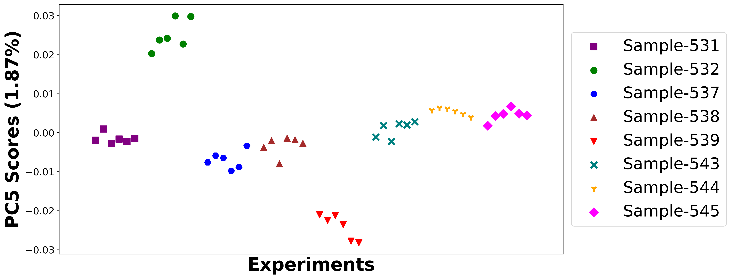

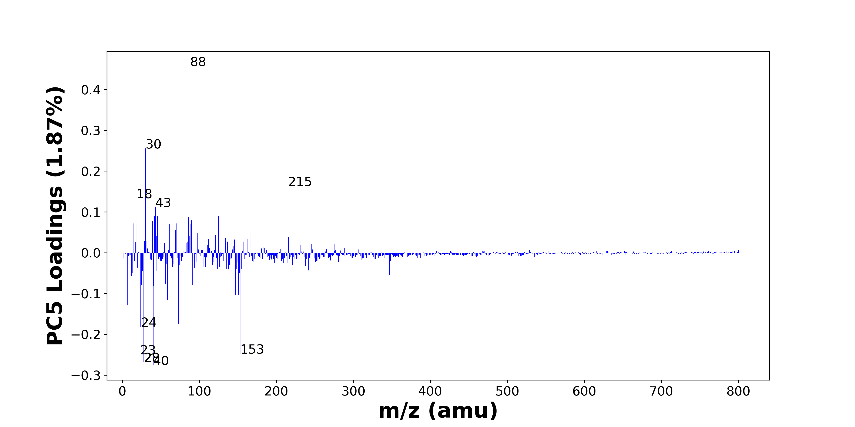

High score samples contain more:

* m/z 88 (C3H8N2O+, C4H10NO+), m/z 30 (CH4N+, 30Si+), m/z 215 (), m/z 18 (NH4+), m/z 43 (C2H5N+, C3H7+, C2H3O+), m/z 31 (OCH3+), m/z 46 (Na2+, C2H8N+), m/z 42 (C2H4N+), m/z 125 (C8H15N+, C9H17+), m/z 86 (C5H12N+), m/z 97 (), m/z 90 (C3H10N2O+), m/z 39 (K+), m/z 19 (OH3+), m/z 70 (C4H8N+, C3H6N2+), m/z 15 (CH3+), m/z 61 (), m/z 89 (), m/z 69 (C3H5N2+), m/z 245 ()
* Hydrocarbons, Oxygen-containing organics, Nitrogen-containing organics

Low score samples contain more:

* m/z 40 (Ca+), m/z 28 (CH2N+, Si+), m/z 23 (Na+), m/z 153 (C10H17O+), m/z 24 (Mg+), m/z 73 (SiC3H9+, FeOH+), m/z 27 (Al+, C2H3+), m/z 7 (Li+), m/z 59 (), m/z 1 (H+), m/z 151 (), m/z 147 (Si2OC5H15+), m/z 154 (), m/z 41 (C3H5+, 41K+), m/z 25 (MgH+, 25Mg+), m/z 91 (C7H7+, C3H9NO2+), m/z 56 (C3H6N+, 56Fe+), m/z 12 (C+), m/z 347 (), m/z 13 ()
* Benzene-containing organics, PDMS

# Positive ion spectra, top positive loadings -- PC5

|  |  |  |  |  |  |  |  |  |
| --- | --- | --- | --- | --- | --- | --- | --- | --- |
| + Loading No. | Unit Mass | Document Mass | Initial Peak Assignment | Initial Probabilities | Measured Mass | Peak Assignment (Qualified) | Updated Peak Assignment (from Document Mass) | Updated Document Mass |
| 1 | 88 | 88.0631 88.0757 | C3H8N2O+ C4H10NO+ | 0.52 0.48 | 88.0651 | C3H8N2O+ C4H10NO+ |  |  |
| 2 | 30 | 30.0339 29.9732 | CH4N+ 30Si+ | 0.591 0.409 | 30.0327 | CH4N+ 30Si+ |  |  |
| 3 | 215 |  |  |  |  |  |  |  |
| 4 | 18 | 18.0339 | NH4+ | 1.0 | 18.0331 | NH4+ |  |  |
| 5 | 43 | 43.0417 43.0543 43.0178 | C2H5N+ C3H7+ C2H3O+ | 0.357 0.33 0.313 | 43.0175 43.0419 43.0540 | C2H5N+ C3H7+ C2H3O+ |  |  |
| 6 | 31 | 31.0179 | OCH3+ | 1.0 |  |  |  |  |
| 7 | 46 | 45.979 46.0652 | Na2+ C2H8N+ | 0.508 0.492 |  |  |  |  |
| 8 | 42 | 42.0338 | C2H4N+ | 1.0 | 42.0351 | C2H4N+ |  |  |
| 9 | 125 | 125.1199 125.1325 | C8H15N+ C9H17+ | 0.525 0.475 | 125.1289 | C8H15N+ C9H17+ |  |  |
| 10 | 86 | 86.0965 | C5H12N+ | 1.0 |  |  |  |  |
| 11 | 97 |  |  |  |  |  |  |  |
| 12 | 90 | 90.0788 | C3H10N2O+ | 1.0 | 90.0795 | C3H10N2O+ |  |  |
| 13 | 39 | 38.9632 | K+ | 1.0 | 38.9610 | K+ |  |  |
| 14 | 19 | 19.0179 | OH3+ | 1.0 |  |  |  |  |
| 15 | 70 | 70.0652 70.0525 | C4H8N+ C3H6N2+ | 0.504 0.496 | 70.0575 | C4H8N+ C3H6N2+ |  |  |
| 16 | 15 | 15.023 | CH3+ | 1.0 |  |  |  |  |
| 17 | 61 |  |  |  |  |  |  |  |
| 18 | 89 |  |  |  |  |  |  |  |
| 19 | 69 | 69.0447 | C3H5N2+ | 1.0 | 69.4093 | C3H5N2+ |  |  |
| 20 | 245 |  |  |  |  |  |  |  |

Note: Highlight colors in the qualified peak assignment column represent the error relative to the measured mass(es) in that row. Green signifies an error < 100ppm, yellow an error from 100 to 200ppm, and red an error > 200ppm.

# Positive ion spectra, top negative loadings -- PC5

|  |  |  |  |  |  |  |  |  |
| --- | --- | --- | --- | --- | --- | --- | --- | --- |
| - Loading No. | Unit Mass | Document Mass | Initial Peak Assignment | Initial Probabilities | Measured Mass | Peak Assignment (Qualified) | Updated Peak Assignment (from Document Mass) | Updated Document Mass |
| 1 | 40 | 39.962 | Ca+ | 1.0 | 39.9500 | Ca+ |  |  |
| 2 | 28 | 28.0182 27.9764 | CH2N+ Si+ | 0.542 0.458 | 27.9745 28.0164 | CH2N+ Si+ |  |  |
| 3 | 23 | 22.9892 | Na+ | 1.0 | 22.9924 | Na+ |  |  |
| 4 | 153 | 153.1274 | C10H17O+ | 1.0 | 153.1137 | C10H17O+ |  |  |
| 5 | 24 | 23.9845 | Mg+ | 1.0 | 23.98726 | Mg+ |  |  |
| 6 | 73 | 73.0469 72.9371 | SiC3H9+ FeOH+ | 0.646 0.354 |  |  |  |  |
| 7 | 27 | 26.981 27.023 | Al+ C2H3+ | 0.57 0.43 | 26.9803 | Al+ C2H3+ |  |  |
| 8 | 7 | 7.0155 | Li+ | 1.0 | 7.0156 | Li+ |  |  |
| 9 | 59 |  |  |  |  |  |  |  |
| 10 | 1 | 1.0073 | H+ | 1.0 | 1.0073 | H+ |  |  |
| 11 | 151 |  |  |  |  |  |  |  |
| 12 | 147 | 147.0656 | Si2OC5H15+ | 1.0 |  |  |  |  |
| 13 | 154 |  |  |  |  |  |  |  |
| 14 | 41 | 41.0386 40.9613 | C3H5+ 41K+ | 0.608 0.392 |  |  |  |  |
| 15 | 25 | 24.9923 24.9853 | MgH+ 25Mg+ | 0.504 0.496 | 24.9901 24.9830 | MgH+ 25Mg+ |  |  |
| 16 | 91 | 91.0543 91.0628 | C7H7+ C3H9NO2+ | 0.514 0.486 |  |  |  |  |
| 17 | 56 | 56.0495 55.9344 | C3H6N+ 56Fe+ | 0.684 0.316 | 56.0438 | C3H6N+ 56Fe+ |  |  |
| 18 | 12 | 11.9995 | C+ | 1.0 |  |  |  |  |
| 19 | 347 |  |  |  |  |  |  |  |
| 20 | 13 |  |  |  |  |  |  |  |

Note: Highlight colors in the qualified peak assignment column represent the error relative to the measured mass(es) in that row. Green signifies an error < 100ppm, yellow an error from 100 to 200ppm, and red an error > 200ppm.

# Positive ion spectra, molecular information from PC5 loadings plot

* The major positive PC5 loadings are m/z 88 (C3H8N2O+, C4H10NO+), m/z 30 (CH4N+, 30Si+), m/z 215 (), m/z 18 (NH4+), m/z 43 (C2H5N+, C3H7+, C2H3O+), m/z 31 (OCH3+), m/z 46 (Na2+, C2H8N+), m/z 42 (C2H4N+), m/z 125 (C8H15N+, C9H17+), m/z 86 (C5H12N+), m/z 97 (), m/z 90 (C3H10N2O+), m/z 39 (K+), m/z 19 (OH3+), m/z 70 (C4H8N+, C3H6N2+), m/z 15 (CH3+), m/z 61 (), m/z 89 (), m/z 69 (C3H5N2+), m/z 245 (), indicating they are more observed in high PC5 score samples.
* The major negative PC5 loadings are m/z 40 (Ca+), m/z 28 (CH2N+, Si+), m/z 23 (Na+), m/z 153 (C10H17O+), m/z 24 (Mg+), m/z 73 (SiC3H9+, FeOH+), m/z 27 (Al+, C2H3+), m/z 7 (Li+), m/z 59 (), m/z 1 (H+), m/z 151 (), m/z 147 (Si2OC5H15+), m/z 154 (), m/z 41 (C3H5+, 41K+), m/z 25 (MgH+, 25Mg+), m/z 91 (C7H7+, C3H9NO2+), m/z 56 (C3H6N+, 56Fe+), m/z 12 (C+), m/z 347 (), m/z 13 (), indicating they are more observed in low PC5 score samples.
* Hydrocarbons signals, such as m/z 15 (CH3+), m/z 43 (C2H5N+, C3H7+, C2H3O+), are mostly found in positive loadings, indicating that high PC5 score samples contain more Hydrocarbons.
* Oxygen-containing organics signals, such as m/z 31 (OCH3+), m/z 19 (OH3+), are mostly found in positive loadings, indicating that high PC5 score samples contain more Oxygen-containing organics.
* Nitrogen-containing organics signals, such as m/z 30 (CH4N+, 30Si+), m/z 70 (C4H8N+, C3H6N2+), m/z 86 (C5H12N+), m/z 18 (NH4+), are mostly found in positive loadings, indicating that high PC5 score samples contain more Nitrogen-containing organics.
* Benzene-containing organics signals, such as m/z 91 (C7H7+, C3H9NO2+), are mostly found in negative loadings, indicating that low PC5 score samples contain more Benzene-containing organics.
* PDMS signals, such as m/z 73 (SiC3H9+, FeOH+), m/z 147 (Si2OC5H15+), are mostly found in negative loadings, indicating that low PC5 score samples contain more PDMS.

